KLH UNIVERSITY
BACHUPALLY
CLOUD INFRASTRUCTURE AND SERVICES
25CS2206E
EXPERIMENT – 1(b)
ENABLING MULTI-FACTOR AUTHENTICATION
TO SECURE YOUR ACCESS
PRACTICAL EXPERIMENT REPORT
Student Name | Teja Hasini Reddy
Course | Cloud Infrastructure and Services
Course Code | 25CS2206E
Academic Year | 2026–2027
Trimester | Even Trimester (T5)

2026–2027 | EVEN TRIMESTER

1. AIM AND OBJECTIVES
Aim: To enable Multi-Factor Authentication (MFA) for an AWS account to provide an additional layer of security during the login process.

Objectives
- Create an IAM user in the AWS Management Console.
- Assign the required permissions to the IAM user.
- Configure a virtual MFA device using an authenticator application.
- Test the authentication process by signing in with the IAM username, password, and MFA code.

2. THEORY

2.1 AWS Identity and Access Management (IAM)
AWS Identity and Access Management (IAM) is the service used to manage identities and control access to AWS resources. It allows an account administrator to create users, assign permissions, and manage authentication credentials.

2.2 IAM User
An IAM user is an identity created within an AWS account. It can be given console access and permissions through AWS managed or customer-managed policies. In this experiment, the IAM user created was named StudentUser01.

2.3 Multi-Factor Authentication (MFA)
Multi-Factor Authentication adds a second verification step to the normal username-and-password login process. A person attempting to sign in must prove their identity using an additional factor, such as a passkey, security key, or code from an authenticator application.

2.4 Virtual MFA and Authenticator Applications
A virtual MFA device is an authenticator application installed on a smartphone or computer. After it is paired with AWS by scanning the displayed QR code, the application generates a six-digit authentication code. AWS verifies the code during sign-in. The setup procedure requires two consecutive codes to confirm that the device is synchronized.

2.5 Authentication Flow
Stage | Action | Purpose
1 | Enter IAM username and password | Verifies the primary login credentials.
2 | Open the authenticator application | Obtains the current six-digit MFA code.
3 | Submit the MFA code | Verifies the second authentication factor.
4 | Access AWS Console | Grants access after successful verification.

3. PREREQUISITES AND TOOLS
- An active AWS account with valid root-user or administrator credentials.
- A web browser and a working internet connection.
- Access to a smartphone or computer for the authenticator application.
- An authenticator application such as Google Authenticator or Microsoft Authenticator.

4. PROCEDURE

PART A – CREATING AN IAM USER
The first part of the experiment creates a separate IAM identity that can be used to access the AWS Management Console.
- Open a web browser and navigate to the AWS Management Console.
- Sign in using the root-user credentials.
- Search for IAM in the AWS Console search bar and open Identity and Access Management (IAM).
- From the navigation pane, select Users and click Create user.
- Enter the username StudentUser01.
- Enable console access for the user and choose a custom or autogenerated password. The recorded review screen showed that a password reset was required at the next sign-in.
The IAM dashboard provides access to user, group, role, and policy management. It is the starting point for creating the new user.
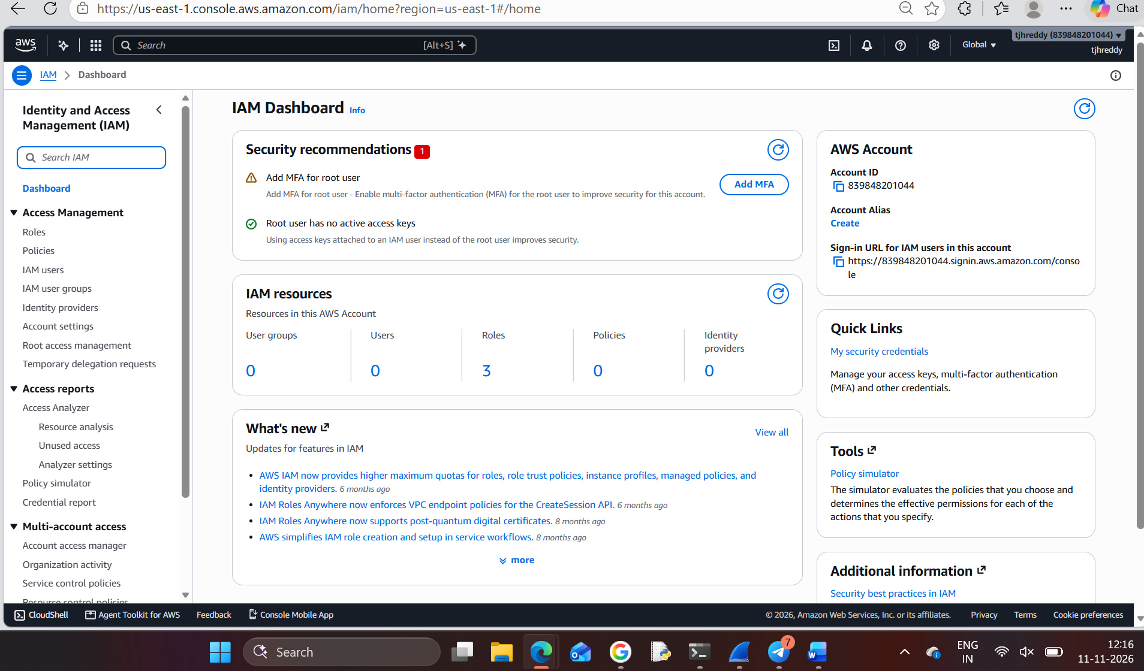
Figure 1. AWS IAM dashboard opened from the AWS Management Console.

PART A – CREATING AN IAM USER (CONTINUED)
- Proceed to Set permissions. The experiment handout specifies attaching the AdministratorAccess AWS managed policy directly to the user.
- Review the permission configuration before creating the user.
- The recorded review screen displayed the policies AdministratorAccess and IAMUserChangePassword.
- Review the username and password settings, then click Create user.
The following screenshots are inserted from the original captures without blurring. AWS itself masks the console password in the retrieve-password screen.
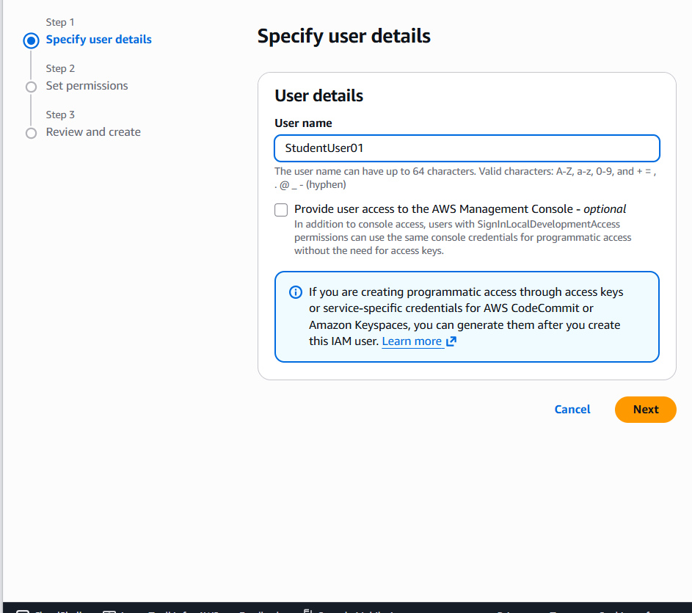  Figure 2. IAM username and console-access setup. | 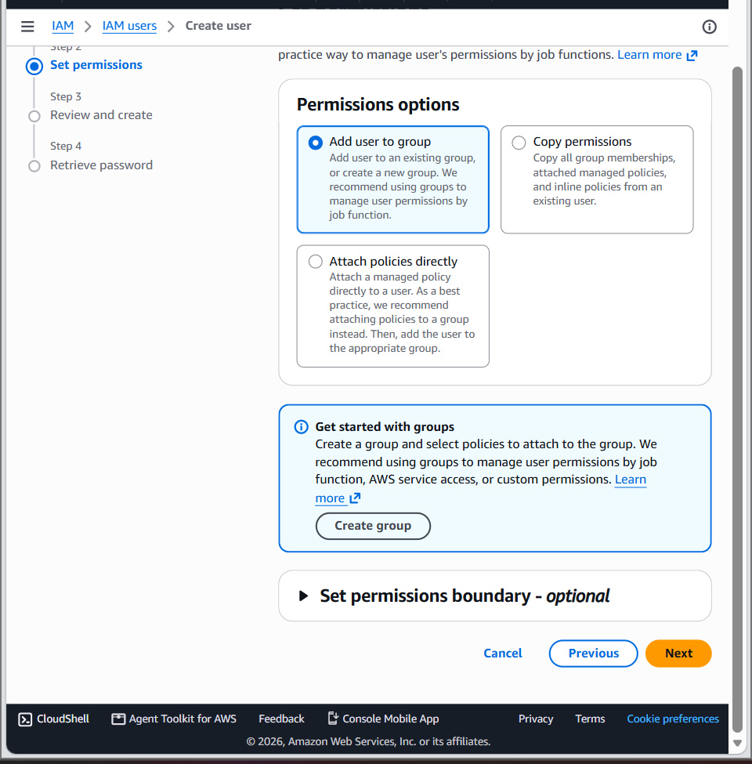  Figure 3. Permissions options during user creation.

Permission Review
Before creating the IAM user, AWS displayed a summary of the user details and attached permissions. The review screen is the final checkpoint for confirming the access configuration.
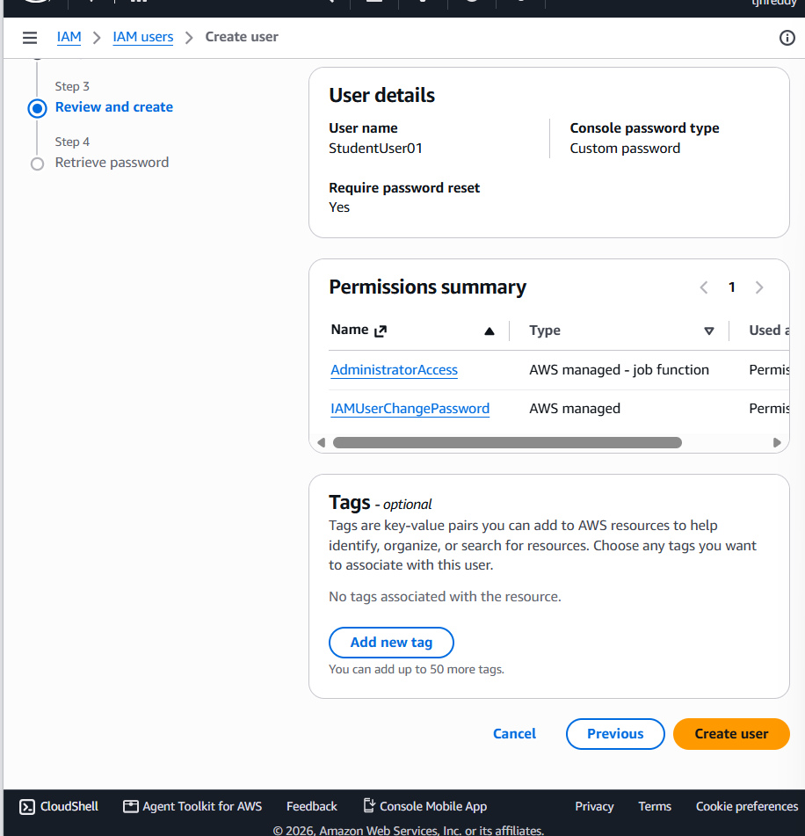
Figure 4. Review screen showing StudentUser01 and the permission summary.

PART A – USER CREATION CONFIRMATION
After selecting Create user, AWS displayed a success notification. The console also provided the IAM user sign-in URL and username. The password was masked in the evidence image and is intentionally not reproduced in this report.
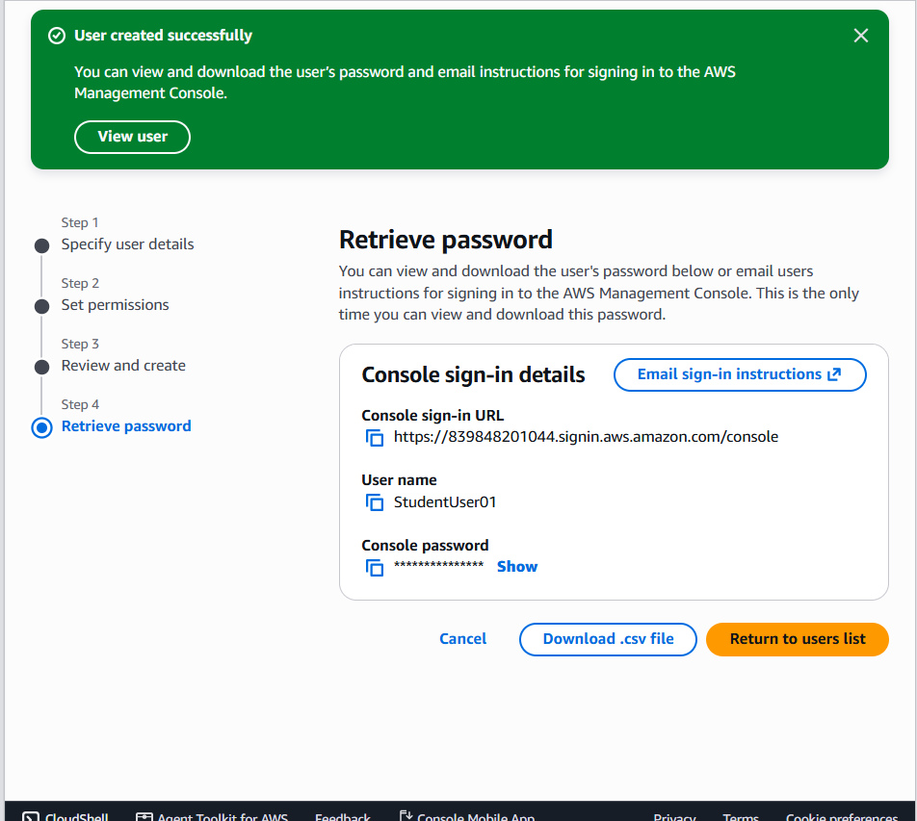
Figure 5. AWS confirmation that the IAM user was created successfully.

PART B – SIGNING IN AS AN IAM USER
- Sign out of the root account.
- Open the IAM user sign-in page using the console sign-in URL provided by AWS.
- Enter the AWS account ID or account alias, the IAM username StudentUser01, and its console password.
- If AWS requests a password change, set a new password and continue.
- Verify that the AWS Management Console opens under the IAM user account.
Recorded AWS account and IAM sign-in details: AWS account ID: 839848201044; AWS Region: us-east-1; IAM username: StudentUser01; IAM user sign-in URL: https://839848201044.signin.aws.amazon.com/console. These values are shown as recorded in the AWS console screenshots. The actual console password is not printed in this report.

PART C – ENABLING MULTI-FACTOR AUTHENTICATION (MFA)
- While signed in as StudentUser01, search for IAM and open the IAM dashboard.
- Select Users, open StudentUser01, and choose the Security credentials tab.
- Locate the Multi-Factor Authentication (MFA) section and click Assign MFA device.
- Enter the device name StudentMFA01.
- Select Authenticator app and click Next.
- Open Google Authenticator or Microsoft Authenticator on the smartphone and add a new account.
- Scan the QR code shown by AWS. The authenticator application will then generate a six-digit code.
- Enter the first code in AWS, wait for the next code, and enter the second code.
- Click Add MFA or Assign MFA to complete registration.
- Confirm that the virtual MFA device is listed as assigned to the IAM user.
The experiment used a virtual authenticator device. The QR code and secret key are sensitive pairing information; they are deliberately excluded from this report.
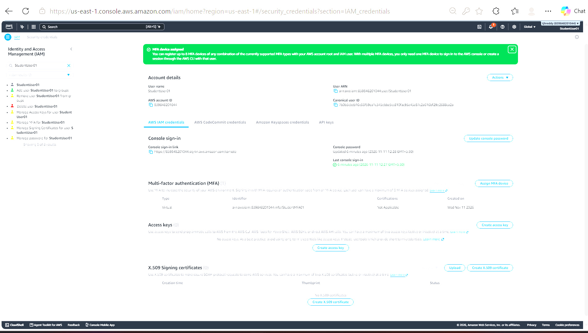
Figure 6. AWS confirmation that a virtual MFA device was assigned successfully.

PART D – TESTING MFA AUTHENTICATION
- Sign out of the AWS Management Console.
- Open the IAM user sign-in page.
- Enter the AWS account ID or alias, IAM username, and password.
- When AWS prompts for MFA, open the authenticator application.
- Enter the current six-digit authentication code and submit it.
- Verify that AWS opens the Management Console after successful MFA verification.
During the first login attempt, the console displayed an authentication-failed message. The console password was then updated from the IAM user's Security credentials page. After using the updated password, the user reached the AWS Console. The MFA prompt was displayed and the authenticator code was entered successfully.
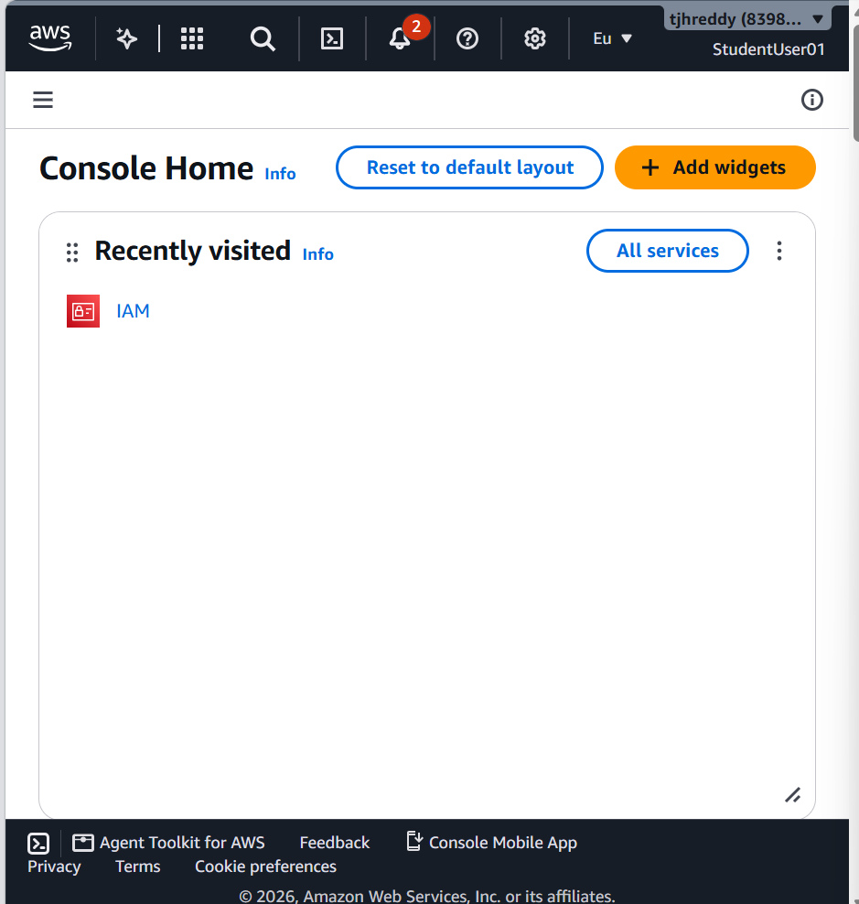
Figure 7. AWS Console Home displayed under StudentUser01 after the MFA sign-in test.

5. OBSERVATIONS AND VERIFICATION
S. No. | Observation | Recorded result
1 | IAM user creation | StudentUser01 was created successfully.
2 | Permission review | AdministratorAccess and IAMUserChangePassword appeared in the review summary.
3 | Console access | The IAM user was able to open the AWS Management Console.
4 | MFA registration | A virtual MFA device named StudentMFA01 was assigned successfully.
5 | MFA authentication test | The MFA prompt appeared during sign-in; the user confirmed successful verification.
6 | Final access | Console Home opened under StudentUser01.

6. TROUBLESHOOTING RECORD
Issue observed: The initial IAM sign-in attempt displayed “Authentication failed. Your authentication information is incorrect.”
Action taken: The IAM user's console password was updated from IAM → Users → StudentUser01 → Security credentials → Update console password. The user then signed in with the updated password.
Outcome: The AWS Console opened successfully. The MFA prompt was also confirmed during the subsequent sign-in test.

7. SECURITY PRECAUTIONS
- Never share the AWS password, six-digit MFA code, QR code, or authenticator secret key. These authentication secrets are not reproduced in this report.
- Store the IAM sign-in URL and username securely.
- Do not include passwords or MFA secrets in screenshots, reports, or public repositories.
- Use the minimum permissions required for normal work. AdministratorAccess provides broad permissions and should be limited to controlled lab use when required by the experiment.
- Keep the authenticator device available and secure because it is needed during MFA sign-in.

8. DISCUSSION
The experiment demonstrates how IAM and MFA work together to protect access to AWS. IAM provides a separate user identity and a way to assign permissions. MFA adds a second verification step after the password. As a result, possession of the password alone is not sufficient to complete a sign-in when MFA is required.
The virtual authenticator application generates temporary six-digit codes. During registration, AWS verifies two consecutive codes to confirm that the authenticator is correctly paired. During the final test, the IAM user signs in with the password and completes the additional MFA verification before reaching the console.

9. RESULT
The IAM user StudentUser01 was created, the required permissions were displayed in the permission review, and a virtual MFA device named StudentMFA01 was assigned successfully. The IAM user completed the MFA sign-in test and accessed the AWS Management Console.

10. CONCLUSION
Multi-Factor Authentication was successfully enabled and tested for the created AWS IAM user. The experiment showed that combining a password with a time-based authenticator code provides an additional layer of protection for AWS console access. The final console screen confirmed that the IAM user could access AWS after completing the authentication process.

11. FUTURE SCOPE
- Apply MFA to privileged users and root-user access as a separate security task.
- Use least-privilege policies instead of broad administrative permissions for routine users.
- Create separate IAM roles and groups to manage access according to responsibilities.
- Maintain secure recovery procedures for cases where an authenticator device is lost or replaced.

12. LEARNING OUTCOMES
- Learned to create an IAM user in the AWS Management Console.
- Understood how permissions are reviewed and assigned to an IAM identity.
- Configured a virtual MFA authenticator application for an IAM user.
- Tested the two-step sign-in process and verified successful AWS console access.
— END OF EXPERIMENT 1(b) —

